What are the multiple lives of religion in South Asia? Consider, for example, its ‘everyday’ aspect and the ways in which it has come to be deployed in the politics of nationalism. Why do you think that religion continues to play such an important role in south Asian lives?

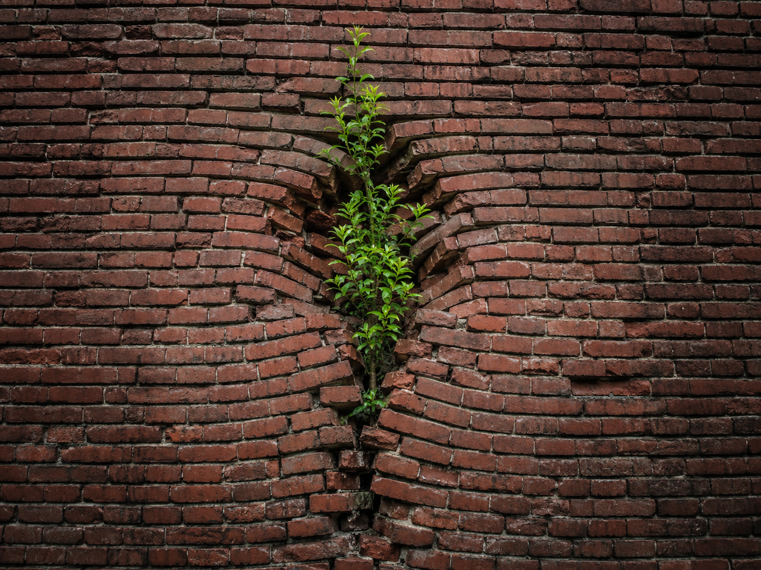
A note for the image:
This is the image in my mind when I try to describe religion in South Asia society. Religion is embedded in the social structure. Compared with more visible categories of social analysis, such as the state, class, economy, law or political institutions, its influence may not always appear immediately visible,but a quiet and gradual way. By “quiet”, I do not mean that religion has been ignored in academic discussions. I mean that religion often works in less visible ways because it is so closely connected to daily life. It grows through the gaps between different domains of life. Like the plant in the image, religion does not belong to one single brick. It grows between the bricks and gradually changes how the whole wall holds together.

This essay begins from the problem of classification. As Nicholas Dirks(2003) suggests, “South Asia” is a field shaped by histories of colonial knowledge, disciplinary formation and power, but not a neutral or natural object of study. The category of “religion” is similarly unstable. In studies of South Asia, religion has often occupied a central place, yet it has also been shaped by Western scholarly and colonial forms of classification. Copeman and Quack（2019）’s thought about contemporary religiosities can help to explain more clear, as it challenges the tendency to treat religion in India as a totalizing explanation of society. They warn that religion in India is often treated as if it simply means Hinduism. This is problematic because it makes Hinduism appear central and pushes other religious and non-religious traditions to the margins.

The category of “New Religious Movements” further shows why religion cannot be treated as a fixed or self-evident object. Srinivas(2019) suggests, the label “new” can be misleading, because many such movements draw on older traditions, including guru-shishya relations, charismatic authority and established ritual forms. The term “movement” may also obscure hierarchical structures organized around gurus and charismatic leaders. Srinivas(2019)’s attention to female gurus and to the afterlife of the guru further complicates the category: religious authority is gendered, embodied and temporally extended. It emerges through female gurus, institutions, disciples, images, objects and ritual memory, and it can continue after the guru’s death.

These problems of classification are important for understanding the “multiple lives” of religion in South Asia. If religion cannot be contained within fixed categories such as Hinduism, tradition, or New Religious Movements, it also cannot be placed easily in one social sphere, such as the household, the nation, or public space. Fadil and Fernando(2015)’s critique of “everyday Islam” warns against treating the everyday as a separate and more authentic domain of religion, opposed to piety, discipline or politics. This essay argues that religion continues to matter in South Asian lives because it moves across these domains. It operates between private and public life, everyday practice and political imagination, intimate self-making and urban space. Its multiple lives lie in this movement across domains.

Intimate religion is not private: body, gender, marriage and time

The first life of religion is its intimate and everyday life. In Huq’s (2021) and Maqsood’s (2023) ethnographies, religion enters the body, dress, marriage, patience and domestic time. These intimate practices are shaped by public visibility, class mobility, gendered expectations, family obligations and wider moral worlds. Religion matters because it turns ordinary practices into sites where private and public life are negotiated together.

Huq’s (2021) study of female university students in Bangladesh makes this point clear. Secular critics often see the growing visibility of Islamic dress among young women as a sign of conservatism. They also read it as a retreat from modernity. Huq complicates this interpretation by placing veiling within histories of class mobility and changing access to higher education. The women who now enter universities are not necessarily from the same elite backgrounds as earlier generations of female students. For some of them, Islamic dress becomes a way of navigating unfamiliar educational and public spaces. Huq’s interlocutors also give different meanings to the hijab. For some, it is tied to comfort, guilt, ethical selfhood or a desire to feel connected to God. For others, it raises anxieties about patriarchal compromise or the male gaze. The hijab connects bodily practice with the university, the street, the family and national debates over secularism and Islam. Through it, women negotiate how they are seen in public, how they are judged as respectable, and how they manage uncertainty about gender, morality and the future. Religion here moves across body, class, family, public space and political debate.

Maqsood(2023) discuss sabar and qismet which extend this argument from the body to marriage and domestic time in urban Pakistan. Marriage may appear to belong to the private household, but Maqsood shows that it is shaped by wider gendered, religious and social expectations. Women may have limited choices in marriage, yet concepts such as sabar and qismet help them make uncertainty livable and meaningful. Through sabar, women wait, endure difference and remain open to change. Through qismet, they interpret limited choices and uncertain futures within a religious understanding of destiny. Religion therefore gives domestic time a wider ethical and social force. It connects present difficulty to future possibility, and links the household to kinship, divine agency and social expectation. This does not mean that women simply accept their situation passively. Their agency appears through waiting, patience, adjustment and interpretation. A woman’s patience may be understood as shaping her husband’s future piety, although this change is never fully under her control. Religion here works in the space between personal aspiration and forces beyond the individual: husbands, kin, destiny, divine will and the unfolding work of time. In this sense, sabar and qismet show how religion lives in the intimate space of marriage while also connecting that space to broader moral and social worlds. In this sense, Maqsood’s ethnography supports the essay’s wider argument: in sabar and qismet, religion moves between the household, gendered agency, divine time and social expectation.

Both Huq and Maqsood’s articles show that the intimate life of religion is not a separate brick in the social structure. The hijab is worn on the body, but it reaches into class mobility, public visibility, gender politics and secular anxieties. Sabar is cultivated in marriage, but it reaches into kinship, divine agency, time and future aspiration. Religion’s everyday life is therefore already public. Religion works through the boundaries between the body, the household, gender, public visibility and moral imagination. This is one reason religion continues to matter in South Asian lives: it gives ordinary practices a wider ethical, social and temporal force.

Materializing public religion: temples, media and urban space

If Huq and Maqsood show that intimate religious practices are already shaped by public worlds, Pati(2019)’s work shows the reverse movement: public religious space is itself produced through everyday devotional practice. Public religion takes shape through the interaction of state planning, nationalist imagination, material forms and everyday practice. Temples, monuments, streets and infrastructures become religiously powerful through repeated acts of worship, movement and narration. Pati discusses the Hanuman Temple in Delhi shows that the public life of religion is sustained by everyday spatial practice. The temple gains significance by gathering devotees, attracting office workers on their way to work, occupying urban space, and resisting the state’s attempts to reorder the city. Its religious power is therefore also spatial and political. The temple’s presence even forces urban infrastructure to adjust around it. City planning can be interrupted, negotiated and reshaped by everyday religious practice. The Hanuman Temple also challenges dominant middleclass visions of Hindu urban space. Monumental spaces such as Akshardham fit more easily into projects of heritage, spectacle and national culture. At the same time, it draws on local myth, informal occupation and everyday devotion. It is clearly Hindu, but it does not fit the clean, orderly, respectable and nationalized Hinduism imagined by middle class urban aesthetics. Pati describes it as a kind of “counterpublic”: a religious public that emerges in tension with dominant visions of the modern, orderly, world-class city. This matters because the temple becomes public through everyday life. People pass through it, pray there, tell stories about it, believe in its power, and make it part of their daily routes. In this sense, the “spectacle” of the temple is made ordinary through practice. What may appear as a religious monument or an urban obstruction is also a lived infrastructure of devotion. It gathers a public through shared acts of worship, movement and spatial attachment. Srinivas (2012) extends this point through urban religious practice. As Bangalore expands and absorbs surrounding villages and towns, festivals such as Karaga become part of wider urban and suburban circuits. Religious practice here is part of urban modernity. It becomes one way through which different actors imagine the city’s past, negotiate its present and contest its future. Religion shapes public space through repeated festivals, routes, built forms and everyday engagements with the city. These practices connect religious imagination to urban memory, planning, movement and a sense of belonging as urban citizens.

A similar process occurs through visual media. Festivals and urban routes connect religion to the city, while VCD images connect religion to a wider national imagination. The case of Islamic deshbhakti(Parciack, 2014) shows how religion also enters public life through visual and media forms. In the VCD images , the Ajmer shrine is superimposed onto the map of India. This image draws on the familiar visual formula of Bharat Mata which is a figure often used in Hindu nationalist visual culture to sacralize the Indian nation. In this Islamic popular media context, however, the formula is reworked to give Islamic symbols a strong place within Indian nation-space. The VCD becomes a material religious mediator: it allows Muslim producers and consumers to circulate images that claim visibility, belonging and symbolic power within the nation. The VCD production allows low-budget actors to enter the media field and bypass more centralized forms of regulation and authority. This is especially important in a context where Muslims are often represented in mainstream media as marginal, voiceless or defective citizens. Through VCDs, Islamic visual culture becomes a way of entering public space and negotiating the symbolic boundaries of Indian citizenship. Religion here lives through images, circulation and media consumption. These media practices allow Muslims to make claims on the nation through popular visual culture.

Pati(2019) and Parciack(2014) therefore show two different material routes through which religion becomes public. In Pati’s ethnography, religion becomes public through temples, roads, monuments and devotional movement. In Parciack’s ethnography, religion becomes public through VCDs, maps, shrine images and popular visual culture. In both cases, religion gains force by attaching itself to material forms that people encounter, carry, watch, visit and move through in everyday life. Religion’s public life emerges through the connections between urban infrastructure, devotional practice, media circulation, and national belonging. These material and social connections allow religion to move across different public worlds.
These examples show that religion’s public life works through the cracks between different “bricks” of the city: the state, the temple, infrastructure, and identity. It attaches to material forms and everyday movements, and gradually reshapes how urban space is imagined, governed, and inhabited. This is why religion continues to matter in South Asian lives: it is rooted in everyday practice while also altering the larger structure of public space.

Conclusion：
Religion in South Asia has multiple lives because it grows through the gaps between different domains of life: the body, household, city, infrastructure, media, identity and public belonging. These lives overlap and reshape one another. Through the hijab, sarbar, temples, and VCD images, religion gives ordinary practices wider ethical, spatial and political force. Its continuing importance comes from this movement across domains. Religion lives through modern forms of embodiment, domestic life, urban space, infrastructure and citizenship, shaping how people inhabit families, cities and nations as moral, religious and political subjects.

Reference:
Copeman, J. and Quack, J. (2019) ‘Contemporary Religiosities’, in S. Srivastava, Y. Arif and J. Abraham (eds.) Critical Themes in Indian Sociology . New Delhi and Thousand Oaks: Sage.

Dirks, N.B. (2003) ‘South Asian Studies: Futures Past’, in D.L. Szanton (ed.) The Politics of Knowledge: Area Studies and the Disciplines . UCIAS Edited Volume 3, Article 9.

Fadil, N. and Fernando, M. (2015) ‘Rediscovering the “Everyday” Muslim: Notes on an Anthropological Divide’, HAU: Journal of Ethnographic Theory , 5(2), pp. 59–88. doi: 10.14318/hau5.2.005.

Huq, S. (2021) ‘Seeking Certainty, Security and Spirituality: Religious Conditioning and Everyday Aspirations amongst Female University Students in Bangladesh’, Contemporary South Asia , 29(2), pp. 257–270.

Maqsood, A. (2023) ‘The Work of Time: Personhood, Agency, and the Negotiation of Difference in Married Life in Urban Pakistan’, Journal of the Royal Anthropological Institute (N.S.), 30, pp. 58–74.

Parciack, R. (2014) ‘Islamic Deshbhakti: Inscribing a Sufi Shrine into the Indian Nation-Space’, Contributions to Indian Sociology , 48(2). doi: 10.1177/0069966714525165.

Pati, S. (2018) ‘Building Monuments in a World Class City: Aesthetics and Politics in Contemporary Delhi’, in U. Skoda and B. Lettmann (eds.) India and its Visual Cultures: Community, Class and Gender in a Symbolic Landscape . New Delhi and Thousand Oaks: Sage, pp. 1–19.

Srinivas, S. (2012) ‘Urban Forms of Religious Practice’, in V. Dalmia and R. Sadana (eds.) The Cambridge Companion to Modern Indian Culture . Cambridge: Cambridge University Press, pp. 67–79.

Srinivas, T. (2019) ‘Artful Living: New Religious Movements in and of South Asia’, in S. Srivastava, Y. Arif and J. Abraham (eds.) Critical Themes in Indian Sociology . New Delhi and Thousand Oaks: Sage.

